**Bird migration connects regions but does not raise local prevalence and richness of avian haemosporidian parasites**

Daniela de Angeli Dutra¹*, Antoine Filion¹, Alan Fecchio², Érika Martins Braga³, Robert Poulin¹

danideangeli@live.com

afilion90@gmail.com

alanfecchio@gmail.com

embraga@icb.ufmg.br

robert.poulin@otago.ac.nz

1.Department of Zoology, University of Otago, Dunedin, New Zealand

2.Programa de Pós-graduação em Ecologia e Conservação da Biodiversidade, Universidade Federal de Mato Grosso, Cuiabá, MT 78060-900, Brazil

3.Departamento de Parasitologia, Instituto de Ciências Biológicas, Universidade Federal de Minas Gerais, Brazil

1.Introduction

Migration has an important impact on the transmission of disease around the world because migrant species can disperse pathogens and parasites between two or more locations and be exposed to more infectious agents (Bauer and Hoye 2014). In this way, migrant species might play an important role in the evolution and distribution of parasites and promote the spread of pathogens to new areas and new hosts species. Besides that, human introduced pathogens and host species can decrease the fitness and survival of resident and native species, compromising the population abundance of local species and reducing community richness (Callaway and Ridenour 2004, Prenter et al. 2004). Conversely, the spread of pathogens might increase host richness by reducing competition pressures and, therefore, avoiding competitive exclusion. Hence, pathogen spread might act as an environmental filter to new species colonization. Several studies have documented the influence of migratory birds on the spread of important pathogens with some of these able to infect humans (Alekseev et al. 2001, Morshed et al. 2005, Poupon et al. 2006, Hellgren et al. 2007, Lindeborg et al. 2012, Ricklefs et al. 2017). Thus, the migratory behavior of birds may influence directly host local richness and population size.

Recently, it was suggested that avian malaria parasites and related haemosporidians, could be used as geographical markers for migratory birds (Marzal 2012). Previous research has demonstrated differences in the timing of the main occurrence of haemosporidian infection in migrating birds. These studies have suggested that differences in haemosporidian lineages could indicate whether birds had become infected in different areas (Marzal 2012). Because migratory birds connect distinct geographic regions they might influence local pathogen transmission. Since most haemosporidians cause life-long infections, parasites may travel across long distances with their bird host during migration. This would therefore allow them to infect new vectors and new avian hosts in novel environments (Fecchio et al. 2020). Indeed, migratory species are known for their potential to connect distant habitats and transfer large amounts of biomass and nutrients between ecosystems (Altizer et al. 2011). Furthermore, O’Connor et al. 2020 have demonstrated that migratory birds do not possess higher immune gene richness in wetter areas, which are usually associated with higher risk of certain infections, such as vector borne diseases. Thereby, migratory birds may be more susceptible to pathogens in those regions. For this reason, it might also be expected that migratory birds harbor a more diverse range of parasites and might be more susceptible to parasite infections.

South America comprises different types of biomes, such as Amazonia, Brazilian Savanna, Atlantic Rain Forest and Pantanal, which hold a great richness of native resident and migratory bird species. Previous research has documented the prevalence of avian malaria in different regions of Brazil, and markedly different prevalence for *Plasmodium* spp have been reported between these regions (Braga et al. 2011). Indeed, the most prevalent avian haemosporidian parasite genus in this region is *Plasmodium* (Braga et al. 2011), however, recent research conducted in Northeast Brazil reported higher prevalence of *Haemoproteus* parasites in this region (unpublished data). *Plasmodium* parasites present higher host-shifting rates than other bird haemosporidians (Hellgren et al. 2007), which could certainly contribute to the dissemination of haemoparasites by migratory birds into new areas. Indeed, host-shifting of a *Plasmodium* species from domestic chicken to wild and native birds has already been reported in Brazil (Ferreira-Junior et al. 2018).

Furthermore, the great avian richness (~3500 species) and abundance in South America (Lepage et al. 2014) could also enhance the probability of parasite host-shifting between migratory and resident birds, given the likely presence of susceptible birds in any particular area. Besides that, the great richness and abundance of vectors could also increase the chances of host-shifting between migratory and resident birds as it increases the chances of compatible vectors being present. Thus, these features make the South American avian haemosporidians a great model to investigate the putative transmission of pathogens via host migration in nature.

In this context, the main goal of this study is to evaluate the influence of migratory birds on the spread of haemosporidian parasites in South America. Specifically, we hypothesize that (1) migratory birds spread parasite lineages along their migratory routes, and (2) localities crossed by more migratory routes have greater prevalence and richness of haemosporidian lineages. For the first hypothesis, we tested whether parasite lineages found (i) only in migratory birds, (ii) in both migrants and residents, and (ii) only in residents, differ in their frequency of occurrence among localities. Due to the fact migrants can carry parasites from many sites and infect resident birds, we predicted that parasite lineages using migratory birds will occur in a greater percentage of localities than those using only resident birds. Moreover, migration behavior increases the exposure of birds to more parasites lineages and hence their contact with different parasites, therefore we expected higher haemosporidian richness and prevalence in regions with more migratory birds. For the second hypothesis, we tested for a relationship among localities between the overall local haemosporidian parasite richness and prevalence, and the proportion of migratory birds passing through a locality.

2. Methods

2.1 Dataset

All the analyses were performed using the MalAvi database (<http://130.235.244.92/Malavi/>) from South American regions and another dataset containing ~13200 bird blood samples from 916 species from 63 different locations sampled from 2005 to 2018 in South America (Figure 1, Supplementary material). Combining both datasets, we obtained a total of ~2800 parasites lineages (all belonging to one of these three genera: *Plasmodium*, *Haemoproteus* and *Leucocytozoon*), representing 506 host species and 156 localities. Each locality was assigned to a biome based on the classification of Turchetto-Zolet et al., 2013. The parasite prevalence was estimated using PCR diagnostic protocols described by Hellgren et al. 2004 and Fallon et al. 2003. The parasite lineages were identified by the PCR protocol described by Hellgren et al. 2004. This protocol produces a *cyt b* fragment of 478 bp. The birds present in each locality were classified into three ecological classes: (1) resident; (2) partial migrant and (3) full migrant, according to the Brazilian Committee of Ornithology Records - CRBO 2014, Somenzari et al. 2018 and BirdLife International (<https://www.birdlife.org/>).

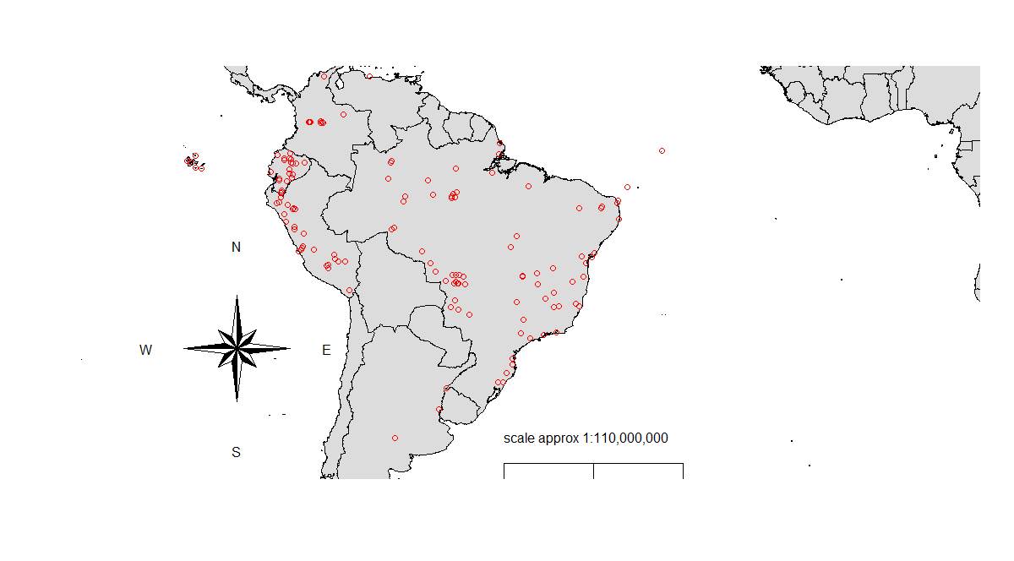

Figure 1: Bird collection points. Collection points comprises a total of 156 areas combining our dataset and the MalAvi database.

2.2 Potential correlates of prevalence and richness

*Spatial and temporal correlation*

All analyses were conducted in R (R Core Team, 2019). We determined whether there was significant spatial autocorrelation for prevalence and parasite richness in our dataset by calculating the Moran Index value. In order to estimate this index, we combined the coordinates data into a matrix and employed the function “Moran.I” from the “Ape” package. Temporal correlation analyses were performed using linear models, to determine whether prevalence or richness estimates varied throughout the sampling period (2005–2018). For parasite prevalence, we conducted a mixed linear model using package “lme4” and the function “lmer”. Firstly, we grouped the data by year and location employing the “group_by” function from the “dplyr” package. Then, we compared the prevalence among years of collection considering number of birds collected and location as variables. For parasite richness, we performed a simple linear model using the “lm” function.

*Phylogenetic Signal*

In order to estimate the phylogenetic signal among prevalence and richness estimates for the bird species in our dataset, we downloaded the file AllBirdsHackett1.tre from <https://birdtree.org/> website. Using the “treeman” package, we created a treeman file containing all trees from the original file. Then, we randomly selected 100 trees. This new file was converted from treeman to a phylo file, from which we extracted one single random tree. Using “dplyr” package, we grouped our data per species and eliminated all bird species from the phylo tree which were not present in our dataset. Using the “match” function from the “picante” package, we matched the species between the tree and our dataset. Then, we calculated Pagel’s lambda (λ) to evaluate the phylogenetic signal among bird species in our dataset, for both haemosporidian prevalence and species richness. Values of λ can range between 0 (no phylogenetic signal) and 1 (strong phylogenetic signal). In order to estimate lambda (λ), we applied the “phylosig” function from the “phytools” package.

2.3 Statistical Analyses

*Bayesian model*

In order to determine whether migratory birds spread parasite lineages along their migratory routes and to evaluate the parasite connectivity among localities due to migratory behavior, we conducted Bayesian analyses using the “brms” package to evaluate the percentage of localities in which haemosporidian lineages occurred depending on whether they were found only in resident birds, only in partial migrant and fully migrant birds, or in both residents and migrants. Firstly, using the “ape” package, we computed the phylogenetic expected variances and covariances from our bird species and incorporated this to control for phylogenetic effects in our Bayesian model. Secondly, we applied the “get_priors” function to fit the priors for our model. We considered as independent and dependent variables bird migratory categories and percentage of localities in which each lineage was present, respectively. We also used as fixed variables the number of birds per site and host richness. As our Moran Index value for spatial autocorrelation of parasite richness among localities was low (-0.0008), we did not consider locality as a variable in our model and also did not use model correction for locality coordinates. Thus, we ran the model applying the “Beta” family, 4 chains with 2000 total iterations per chain and 50% of warmup interactions. The model results were plotted using the “conditional_effects” function. We ran three models: one for all three parasite genera combined, one for *Plasmodium* lineages only, and one for *Haemoproteus* lineages only.

*Mixed models*

Two mixed models were performed to estimate whether localities with more migratory birds have greater prevalence and richness of haemosporidian lineages. With this objective, we employed the “lmer” function from “lme4” package. In the first model, we considered parasite richness as the dependent variable and percentage of migratory bird individuals (i.e., percentage of migratory individuals out of all individual birds sampled in a locality) as independent variable. Local host richness (i.e., number of bird species sampled per locality), prevalence, percentage of migratory species and number of migrant individuals were considered fixed variables. Further, the number of individual birds tested for infection per site, biome, mean precipitation and temperature were included as random variables.

In the second model, we analyzed the prevalence of infection in each bird species between localities using biome and locality as random variables. For this we considered local prevalence in each bird species as our dependent variable and local percentage of migratory birds as our independent variable. In this model, we filtered our data in order to include only species with 10 or more bird individuals analysed. For this second model we used only our dataset described above and excluded data from the MalAvi database, since the latter presents only positive and sequenced samples. Again, we ran three models: one for all three parasite genera combined, one for *Plasmodium* lineages only, and one for *Haemoproteus* lineages only.

3. Results

The spatial and temporal autocorrelation analyses revealed there is no substantial effect of time or space on parasite richness, however, for prevalence, we observed a Moran Index effect of 0.15, and for this reason, locality was used as a random effect in our second mixed model. Likewise, considerable phylogenetic signals were observed among bird species for prevalence (0.49) and parasite richness (0.17). Considering this, phylogenetic covariation was added in Bayesian analyses and species were used as factors in the second mixed model.

Our analyses demonstrate that bird migratory behavior increases the distribution of haemosporidian lineages but does not increase local richness and prevalence of these parasites in avian hosts. Our Bayesian model analyses revealed the lineages shared by resident and migratory species are the most widespread spatially, as they are found in a higher percentage of locations (Figure 2, Table 1). When considering all haemosporidian genera together, we observed that the lineages shared by all three categories (resident, partial migrant and full migrant) are the most widespread, followed by those shared between residents and either type of migratory species. Nevertheless, despite the fact lineages shared by migratory species and residents are more widely distributed, lineages present in only residents, migratory or partially migratory species show similar spatial distribution in our model. Lineages present in all bird categories were present in 4.5% (SE = ±0.5%) of localities, meanwhile lineages present in resident and full migratory or partial migratory were observed in 2.3% (SE = ±0.2%) and 2% (SE = ±0.2%) of localities. In addition, linages observed in full migratory, partial migratory or resident were found in 1% (SE = ±0.03%), 0.9% (SE = ±0.01%) and 1% (SE = ±0.01%) of localities respectively.

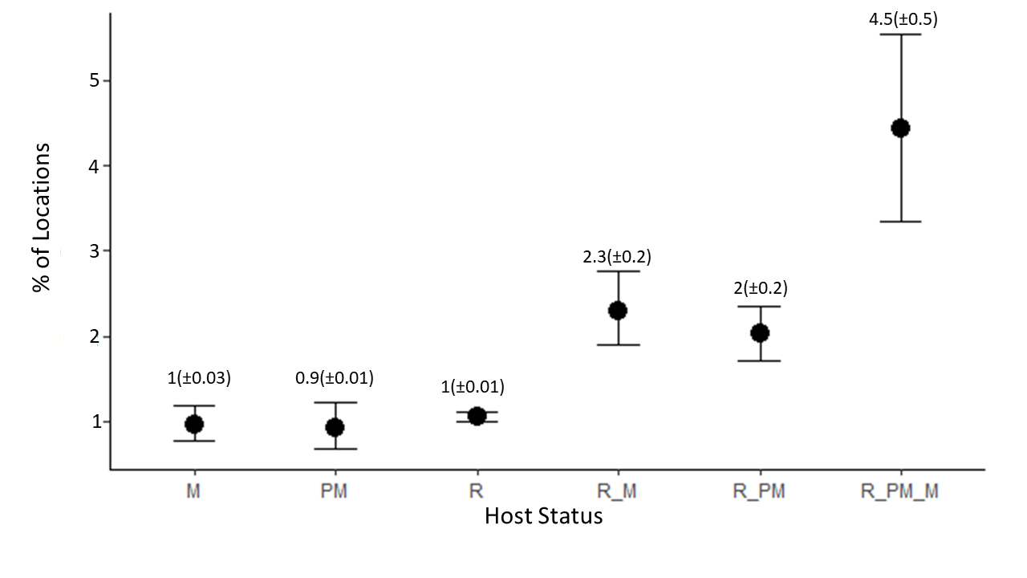

Figure 2: Bayesian model plot. Model demonstrates lineages shared by migratory species and resident are more spread. M = full migratory, PM = partial migratory, R = resident, R_M = resident and full migratory, R_PM = resident and partial migratory and R_PM_M = resident, partial migratory and full migratory.

When repeating these analyses separately for the two main parasite genera, we observed differences in the pattern of distribution between *Plasmodium* and *Haemoproteus*. For *Plasmodium* parasites, we observed a much greater spatial distribution of lineages shared by all three host categories, followed by the lineages shared by migrant or partial migrant and residents (Figure 3, Table 2). *Plasmodium* spp. lineages occurring in the three bird categories were present in 12.6% (SE = ±1.2%) of localities, a much higher value than for other lineages. meanwhile lineages present in resident and full migratory or partial migratory were observed in 2.3% (SE = ±0.35%) and 2.3% (SE = ±0.25%) of localities. We also observed that linages present only in full migratory, partial migratory or resident birds were present only in 0.8% (SE = ±0.02%), 0.9% (SE = ±0.02%) and 1% (SE = ±0.005%) of localities respectively.

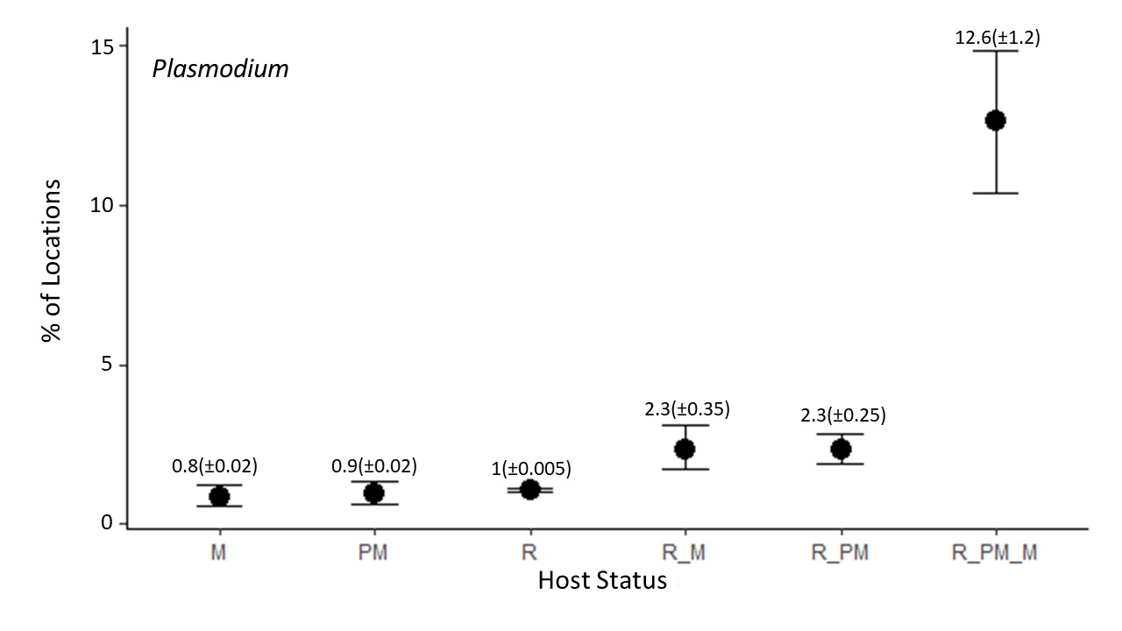

Figure 3: Bayesian model plot for *Plasmodium* spp.. Model demonstrates lineages shared by migratory species and resident are more spread. M = full migratory, PM = partial migratory, R = resident, R_M = resident and full migratory, R_PM = resident and partial migratory and R_PM_M = resident, partial migratory and full migratory.

However, for *Haemoproteus* lineages, we observed greater spatial distribution of lineages shared only by migrant or partial migrant and resident birds. The lineages shared by all three bird categories and those occurring in only one bird category had similar distributions among localities (Figure 4, Table 3). Lineages present in resident and full migratory or partial migratory were observed in 2.6% (SE = ±0.3%) and 1.7% (SE = ±0.2%) of localities. In addition, linages observed in full migratory, partial migratory and resident birds were found in 0.9% (SE = ±0.01%), 0.8% (SE = ±0.02%) and 1% (SE = ±0.001%) of localities respectively. Further, lineages observed in all bird categories were found in 1% (SE = ±0.3%).

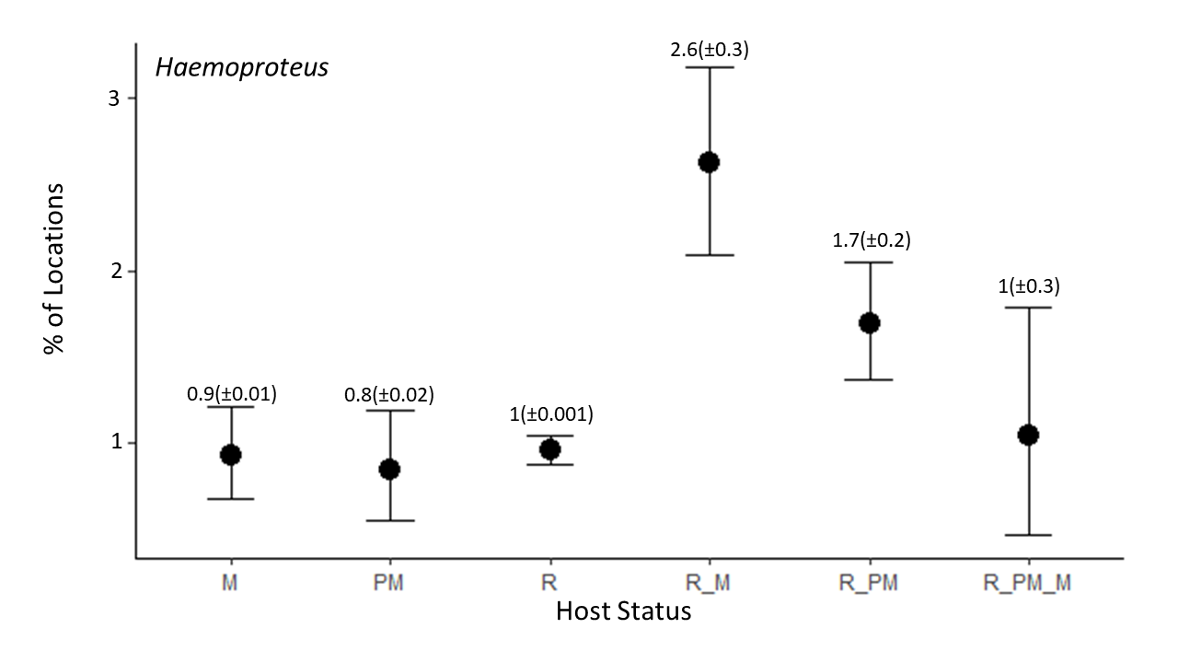

Figure 4: Bayesian model plot for *Haemoproteus* spp.. Model demonstrates lineages shared by one category of migratory species and resident are more spread. M = full migratory, PM = partial migratory, R = resident, R_M = resident and full migratory, R_PM = resident and partial migratory and R_PM_M = resident, partial migratory and full migratory.

Our first mixed model revealed that there is no correlation between the percentage of migratory bird individuals per locality and local parasite richness (p = 0.19, Figure 3, Table 4). We also observed no effect of the percentage of migratory bird individuals on parasite richness when *Plasmodium* and *Haemoproteus* infections were treated separately (p = 0.55, p = 0.94, respectively; see Supplementary Material).

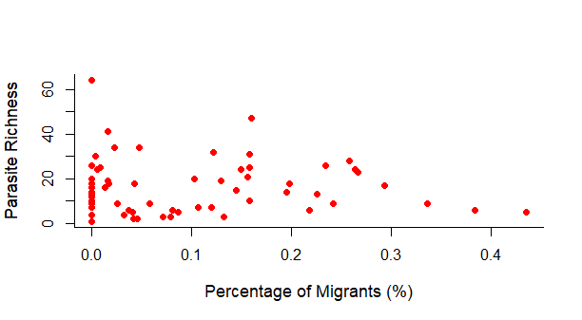

Figure 3: Local richness of haemosporidian parasites as a function of the percentage of migratory individuals out of all bird individuals sampled per locality. Each point represents a different locality. No correlation was found between percentage of migratory individuals and haemosporidian richness (p = 0.19).

For the second model, in which we analysed the relationship between local prevalence per bird species and local percentage of migratory bird individuals, we observed a negative correlation between migratory behavior and prevalence of haemosporidian parasites per species (p=0.04, Figure 5, Table 5). However, when we repeated the analysis separately for only *Plasmodium* or *Haemoproteus* lineages, we observed no relation between percent of migrants and prevalence per host species (p = 0.08, p = 0.34, see Supplementary Material). None of the other predictors had any significant on prevalence per bird species, whether when considering all haemosporidian lineages (Table 5), or only *Plasmodium* or *Haemoproteus* lineages (Supplementary Material Tables S3 and S4).

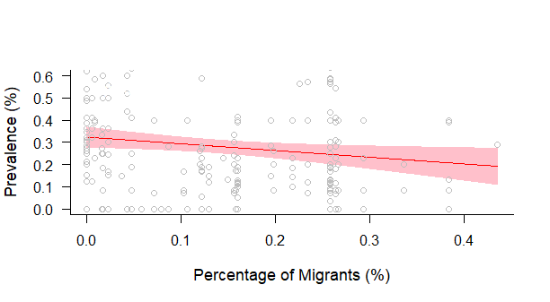

Figure 4: Correlation between prevalence of haemosporidian parasites and percentage of migratory host individuals per locality. Each point represents the prevalence value per host species per site. We observed a negative effect between migratory behavior and parasite prevalence (p = 0.04).

References

Alekseev, A. N. et al. 2001. Evidence of Ehrlichiosis Agents Found in Ticks ( Acari : Ixodidae ) Collected from Migratory Birds Evidence of Ehrlichiosis Agents Found in Ticks ( Acari : Ixodidae ) Collected from Migratory Birds. - J. Med. Entomol. 38: 471–474.

Altizer, S. et al. 2011. Animal migration and infectious disease risk. - Science (80-. ). 331: 296–302.

Bauer, S. and Hoye, B. J. 2014. Migratory animals couple biodiversity and ecosystem functioning worldwide. - Science (80-. ). in press.

Braga, É. M. et al. 2011. Recent advances in the study of avian malaria: An overview with an emphasis on the distribution of Plasmodium spp in Brazil. - Mem. Inst. Oswaldo Cruz 106: 3–11.

Callaway, R. M. and Ridenour, W. M. 2004. Novel weapons: Invasive success and the evolution of increased competitive ability. - Front. Ecol. Environ. 2: 436–443.

Comitê Brasileiro de Registros Ornitológicos - CRBO 2014. Listas das aves do brasil. - Com. Bras. Regist. Ornitológicos: 1–38.

Fallon, A. S. M. et al. 2003. Detecting Avian Malaria : an Improved Polymerase Chain Reaction Diagnostic Detecting Avian Malaria : an Improved Polymerase Chain. 89: 1044–1047.

Fecchio, A. et al. 2020. Evolutionary ecology, taxonomy, and systematics of avian malaria and related parasites. - Acta Trop.: 105364.

Ferreira-Junior, F. C. et al. 2018. A new pathogen spillover from domestic to wild animals: Plasmodium juxtanucleare infects free-living passerines in Brazil. - Parasitology: 1–10.

Hellgren, O. et al. 2004. A New Pcr Assay For Simultaneous Studies Of Leucocytozoon, Plasmodium, And Haemoproteusfrom Avian Blood. 90: 797–802.

Hellgren, O. et al. 2007. Detecting shifts of transmission areas in avian blood parasites - A phylogenetic approach. - Mol. Ecol. 16: 1281–1290.

Lepage, D. et al. 2014. Avibase - A database system for managing and organizing taxonomic concepts. - Zookeys: 117–135.

Lindeborg, M. et al. 2012. Migratory Birds, Ticks, and Crimean-Congo Hemorrhagic Fever Virus. - Emerg. Infect. Dis. 18: 2095–2097.

Marzal, A. 2012. Recent Advances in Studies on Avian Malaria Parasites. - Malar. Parasites: 135–158.

Morshed, M. G. et al. 2005. Migratory songbirds disperse ticks across Canada, and first isolation of the Lyme disease spirochete, Borrelia burgdorferi, from the avian tick, Ixodes auritulus. - J. Parasitol. 91: 780–790.

O’Connor, E. A. et al. 2020. Wetter climates select for higher immune gene diversity in resident, but not migratory, songbirds. - Proceedings. Biol. Sci. 287: 20192675.

Poupon, M. et al. 2006. Prevalence of Borrelia burgdorferi Sensu Lato in Ticks Collected from Migratory Birds in Switzerland Prevalence of Borrelia burgdorferi Sensu Lato in Ticks Collected from Migratory Birds in Switzerland. - Appl. Environ. Microbiol. 72: 976–979.

Prenter, J. et al. 2004. Roles of parasites in animal invasions. - Trends Ecol. Evol. 19: 385–390.

Ricklefs, R. E. et al. 2017. Avian migration and the distribution of malaria parasites in New World passerine birds. - J. Biogeogr. 44: 1113–1123.

Somenzari, M. et al. 2018. An overview of migratory birds in Brazil.

Turchetto-Zolet, A. C. et al. 2013. Phylogeographical patterns shed light on evolutionary process in South America. - Mol. Ecol. 22: 1193–1213.

Table 1: Parameter estimates, standard errors, and p values for the Bayesian model testing the differences in the distribution of haemosporidian lineages among those that occur in migratory and/or resident avian host species.

|  |  |  |  |
| --- | --- | --- | --- |
|  | **Estimate** | **Std. error** | **p** |
| Full migrant | -4.64 | 0.11 | 0.0 |
| Partial migrant | -0.04 | 0.18 | 0.81 |
| Resident | 0.09 | 0.11 | 0.42 |
| Resident and full migrant | 0.88 | 0.15 | 0.0 |
| Resident and partial migrant | 0.76 | 0.14 | 0.0 |
| Resident, partial and full migrant | 1.56 | 0.17 | 0.0 |

Table 2: Parameter estimates, standard errors, and p values for the Bayesian model testing the differences in the distribution of *Plasmodium* spp. lineages among those that occur in migratory and/or resident avian host species.

|  |  |  |  |
| --- | --- | --- | --- |
|  | **Estimate** | **Std. error** | **p** |
| Full migrant | -4.77 | 0.20 | 0.0 |
| Partial migrant | 0.08 | 0.28 | 0.76 |
| Resident | 0.24 | 0.20 | 0.24 |
| Resident and full migrant | 1.03 | 0.25 | 0.0 |
| Resident and partial migrant | 1.02 | 0.23 | 0.0 |
| Resident, partial and full migrant | 2.83 | 0.23 | 0.0 |

Table 3: Parameter estimates, standard errors, and p values for the Bayesian model testing the differences in the distribution of *Haemoproteus* spp. lineages among those that occur in migratory and/or resident avian host species.

|  |  |  |  |
| --- | --- | --- | --- |
|  | **Estimate** | **Std. error** | **p** |
| Full migrant | -4.68 | 0.15 | 0.0 |
| Partial migrant | -0.10 | 0.24 | 0.70 |
| Resident | 0.04 | 0.16 | 0.86 |
| Resident and full migrant | 1.07 | 0.19 | 0.0 |
| Resident and partial migrant | 0.61 | 0.18 | 0.0 |
| Resident, partial and full migrant | 0.09 | 0.37 | 0.75 |

Table 4: Parameter estimates, standard errors, and p values for the mixed model testing the variation of haemosporidian richness as a function of the percentage of migratory individuals out of all individual birds sampled per locality, as well as other potential predictors.

|  |  |  |  |
| --- | --- | --- | --- |
|  | **Estimate** | **Std. error** | **p** |
| Percentage of migrant individuals | -33.05 | 24.90 | 0.18 |
| Host richness | 0.3 | 0.16 | >0.001 |
| Prevalence | 0.44 | 0.07 | >0.001 |
| Percentage of migrant species | 0.09 | 0.30 | 0.77 |
| Number of migrants | 0.08 | 0.26 | 0.0013 |

Table 5: Parameter estimates, standard errors, and p values for the mixed model testing the variation of local haemosporidian prevalence per species as a function of the percentage of migratory individuals out of all individual birds sampled per locality, as well as other potential predictors.

|  |  |  |  |
| --- | --- | --- | --- |
|  | **Estimate** | **Std. error** | **p** |
| Percentage of migrant individuals | -1.36 | 0.05 | 0.04 |
| Host richness | >0.001 | >0.001 | 0.69 |
| Parasite richness | -0.001 | 0.001 | 0.40 |
| Percentage of migrant species | 0.009 | 0.007 | 0.21 |
| Number of migrants | -0.001 | 0.001 | 0.27 |